Infosys Springboard Virtual Internship 6.0 Completion Report

Team Details
Batch Number:6 NeuroFleetX – AI powered urban fleet and traffic intelligence
Start date : 10-Nov-2025
Name: Harshavarthini
Internship Duration: 8 Weeks

1. Project Title
NeuroFleetX – AI Powered Smart Delivery and Logistics System

2. Project Objective
NeuroFleetX is an AI-powered smart delivery and logistics system designed to address the growing challenges of urban delivery management. The primary objective of this project is to provide an intelligent and centralized platform that enables administrators to efficiently manage delivery operations while assisting drivers with optimized routing and task execution. By leveraging modern web technologies and AI-driven concepts, It aims to improve visibility, coordination, and decision-making across the delivery lifecycle. The system focuses on real-time monitoring of delivery personnel, assignment of delivery tasks, and visualization of delivery routes using interactive dashboards. It enhances operational efficiency by reducing manual tracking, minimizing delivery delays, and improving communication between administrators and drivers. Through role-based access, the platform ensures secure and personalized experiences for different users. Ultimately, It seeks to create a scalable and user-friendly logistics solution that can be extended with advanced AI features such as traffic prediction, route optimization, and performance analytics, thereby improving delivery speed, service quality, and overall operational effectiveness.

3. Project description in detail
The frontend module of NeuroFleetX is designed as an interactive web interface that acts as the visual layer of the AI-powered logistics system. It provides role-based access to Admin and Driver dashboards, enabling users to view delivery information in a structured and intuitive manner.
The frontend is developed using React.js, HTML, CSS, and JavaScript, focusing on clean UI design, responsive layouts, and smooth navigation. The dashboard module plays a critical role by presenting delivery-related information in an organized format using cards, sections, and clearly separated components.
My Contribution – Dashboard Development
My primary responsibility in this project was the design and implementation of the Frontend Dashboard pages for both Admin and Driver roles.
Admin Dashboard
The Admin Dashboard is designed to provide an overview of system operations. It presents delivery summaries and system-level information using dashboard cards and structured sections. The layout emphasizes clarity and accessibility, allowing administrators to quickly understand operational status.
Driver Dashboard
The Driver Dashboard focuses on delivery-specific information relevant to drivers. The interface is simplified to ensure ease of use while on duty. Delivery status, task details, and essential updates are displayed using a clean card-based layout.
Dashboard UI Design & Styling
- Used CSS Flexbox for responsive alignment and layout structure
- Implemented consistent color schemes and typography for readability
- Designed card-based UI components to visually separate data
- Maintained proper spacing, alignment, and visual hierarchy
- Ensured dashboards are responsive across different screen sizes
The dashboard design focuses on usability, ensuring that users can quickly understand information without clutter. The frontend dashboard serves as a bridge between backend data and end-users, making logistics operations easier to manage.
4. Timeline Overview
Week | Activities Planned | Activities Completed
Week 1 | Requirement analysis and understanding project scope | Identified frontend requirements, user roles (Admin & Driver), and dashboard functionalities
Week 2 | UI wireframe planning and React project setup | React frontend structure initialized with routing and folder organization
Week 3 | Login & role-based navigation implementation | Functional login flow for Admin and Driver dashboards
Week 4 | Admin Dashboard UI development | Designed summary cards, order creation form, and delivery table layout
Week 5 |  | Implemented delivery assignment view with accept/reject functionality
  Driver Dashboard UI development
Week 6 |  | Improved UI using Flexbox, spacing, color consistency, and responsive layout
  CSS styling and responsive design
Week 7 | Integration with backend APIs | Displayed dynamic delivery data on dashboards
Week 8 | Testing, UI refinement, and documentation | Verified UI behavior, fixed alignment issues, finalized frontend documentation

5a. Key Milestones
Milestone | Description | Date Achieved
Project Kickoff | Project requirements finalized and frontend responsibilities assigned | 17 – Nov- 2025
Prototype/First Draft | Developed initial frontend prototype including login page and basic dashboard layout using React and CSS. | 29 – Nov - 2025
Mid-Term Review | Completed mid-term review, demonstrated dashboard UI flow, and refined layouts and components based on feedback. | 14 - Dec - 2025
Final Submission | Completed frontend dashboards for Admin and Driver with full UI functionality, API integration, and styling. | 29 - Dec - 2025
Presentation | Prepared and delivered project presentation explaining frontend dashboards, workflow, and user experience. | 2- Jan - 2026

5b. Project execution details
Requirement Analysis – Analyzed the problem of inefficient urban delivery management, identified user roles (Admin and Driver), and finalized frontend dashboard requirements.
• Technology Selection – Selected React.js for frontend development, CSS3 for styling, JavaScript for interactivity, Node.js for execution, and REST APIs for backend communication.
• System Design – Designed UI layouts for Admin and Driver dashboards, defined navigation flow, and planned role-based access to dashboard features.
• Frontend Architecture Setup – Organized the React project structure with reusable components, routing, and separate CSS files for maintainability.
• Admin Dashboard Development – Implemented admin dashboard features including delivery statistics cards, order creation form, delivery listing table, and map view access.
• Driver Dashboard Development – Developed driver dashboard to display assigned orders, job notifications, accept/reject actions, and live delivery status updates.
• UI Styling and Responsiveness – Applied consistent color schemes, spacing, typography, and responsive layouts using Flexbox to ensure usability across devices.
• Backend Integration – Integrated frontend dashboards with backend APIs to fetch and display real-time delivery and driver data.
• Testing & UI Refinement – Conducted functional and UI testing, fixed layout issues, improved alignment, and ensured smooth navigation.
• Documentation & Presentation – Prepared frontend documentation, screenshots, and presentation material for Infosys milestone reviews and final evaluation.

6. Snapshots / Screenshots
Step 1: Start the Frontend Application
Navigate to the frontend folder (traffic-dashboard) and run:
- npm install
- npm start
The application opens in the browser at http://localhost:3000
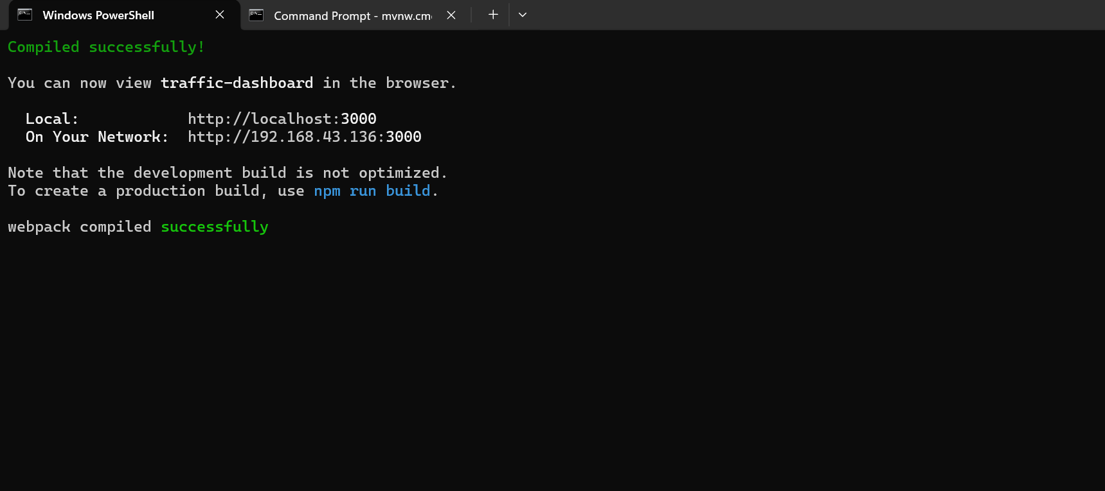

Step 2: Login Page – Driver Access
The login page allows users to select their role.
Here, the Driver selects the Driver role and logs in using valid credentials.

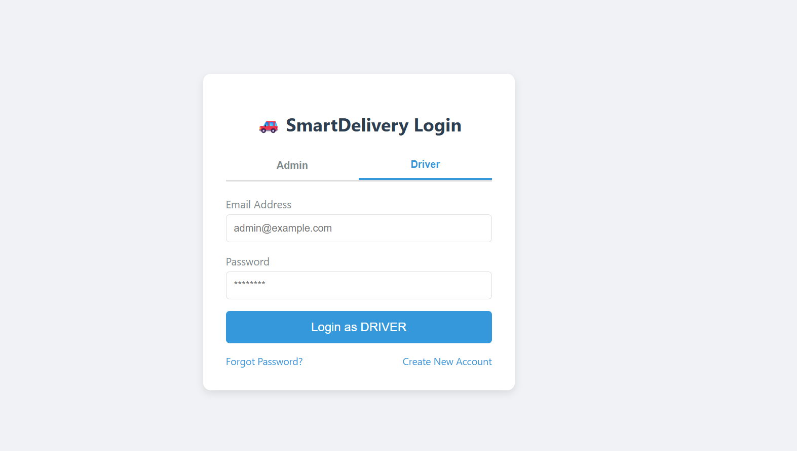

Step 3: Driver Authentication
After clicking on the Login/Signup option, the driver is redirected to the authentication page.Here, the driver registers by selecting the Driver role and entering details such as full name, email, password, and vehicle type.The system performs role-based authentication to ensure secure access and restricts unauthorized users.Upon successful authentication, the driver is redirected to the Driver Dashboard.

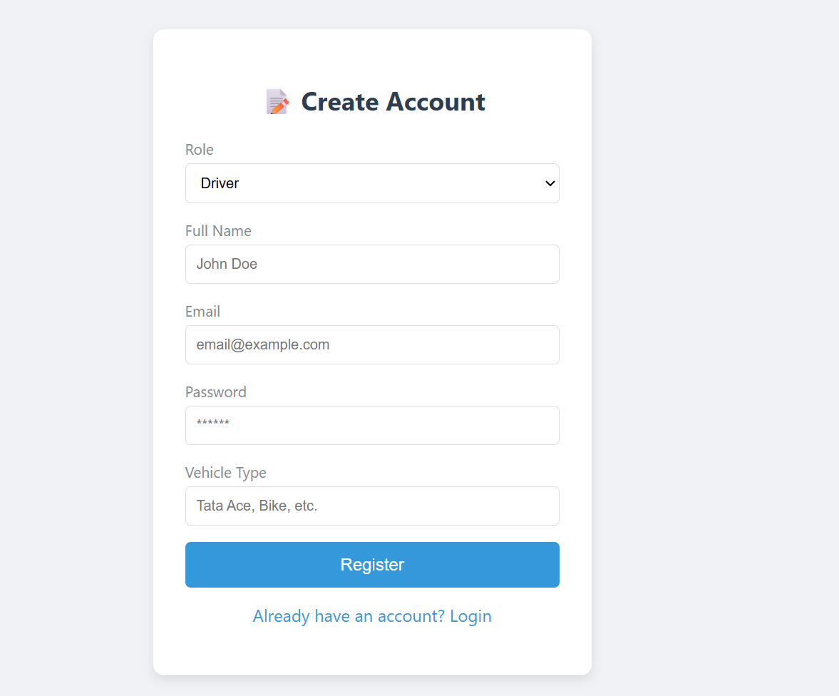

Step 4: The Driver Dashboard displays:
- Driver-specific information
- Assigned delivery details
- Clean and responsive layout for easy usage
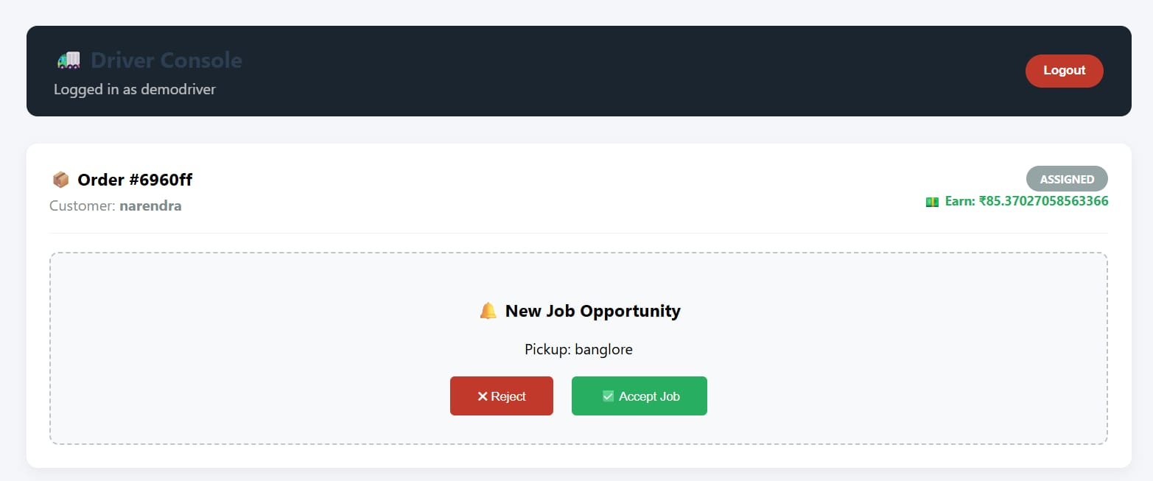

Step 5: Live Location Display
The dashboard shows the current location of the driver on the map.
The location updates dynamically to simulate real-time movement.
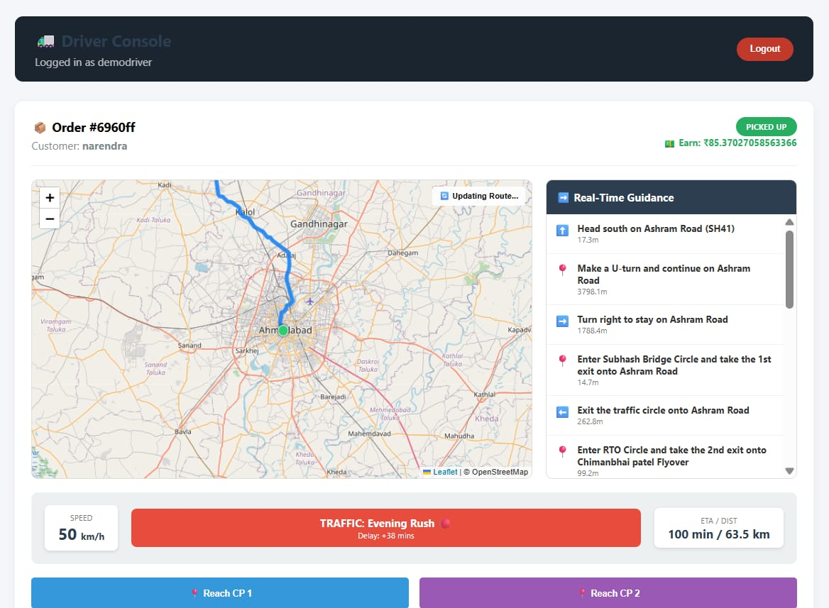

Step 6: Route Visualization
The system visually displays:
- Optimized delivery route
- Start location and destination
- Traffic-aware paths highlighted on the map
This helps the driver choose efficient routes.
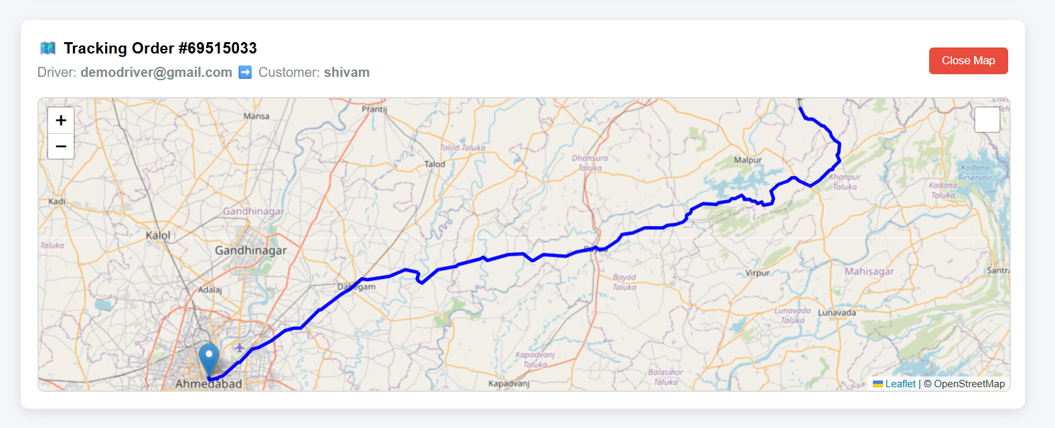

Step 7: Delivery Navigation Support
The driver can:
- View destination details
- Track movement live on the map
- Follow system-recommended routes
Step 8:Responsive UI Design
The Driver Dashboard is designed using CSS and Flexbox to ensure:
- Proper alignment
- Clear spacing
- Smooth navigation across different screen sizes

Step 9: Real-Time Monitoring Experience
The dashboard continuously updates the driver’s position and route visualization, creating a real-time delivery tracking experience.

7. Challenges Faced
• Real-Time Data Simulation – Since live traffic and delivery APIs were not fully available, simulating real-time driver movement and order status updates was challenging.
• Role-Based Dashboard Design – Designing separate dashboards for Admin and Driver with different permissions and views required careful UI planning.
• Frontend–Backend Integration – Ensuring smooth data flow between frontend dashboards and backend APIs caused synchronization issues during development.
• State Management – Managing order status, driver assignments, and UI updates dynamically in React required proper state handling.
• Map Integration – Integrating map views for route visualization and ensuring smooth rendering without performance lag was challenging.
• Responsive Design – Making dashboards responsive across different screen sizes while maintaining usability needed multiple CSS iterations.
• UI Consistency – Maintaining consistent color schemes, typography, and layout across login, admin, and driver dashboards took refinement.
• Error Handling – Displaying meaningful UI feedback for failed API calls, empty data, or invalid inputs required additional validation logic.
• Testing Dashboards – Testing different delivery scenarios such as assigned, accepted, and completed orders was time-consuming.
• Time Management – Balancing frontend dashboard development with coordination among team members within the internship timeline was demanding.

8. Learnings & Skills Acquired

• Frontend Development with React.js – Gained strong hands-on experience in building interactive dashboards using React components.
• UI/UX Design Skills – Learned how to design clean, intuitive, and role-based user interfaces for real-world logistics systems.
• CSS & Responsive Design – Improved skills in Flexbox, layout alignment, spacing, and responsive UI design.
• Dashboard Design Principles – Understood how to present real-time data using cards, tables, and sections for clarity and usability.
• API Integration – Learned how to connect frontend dashboards with backend services and handle asynchronous data updates.
• Map & Visualization Handling – Gained experience in displaying routes, locations, and delivery tracking using map-based UI elements.
• State & Event Management – Improved understanding of managing application state and user interactions efficiently.
• Testing & Debugging – Strengthened debugging skills by identifying UI bugs and resolving integration issues.
• Team Collaboration – Improved coordination by working alongside backend developers and dividing responsibilities effectively.
• Real-World System Understanding – Gained practical knowledge of smart delivery systems, fleet management, and logistics workflows.

9. Testimonials from team

Team Member 1:
"Working on NeuroFleetX helped me understand how AI and traffic intelligence can be applied to real-world delivery systems. I gained experience in backend integration and delivery workflow logic.”

Team Member 2:
“This project gave me hands-on exposure to frontend development using React. Designing dashboards and implementing responsive UI improved my understanding of user-centered design.”

Team Member 3
“NeuroFleetX taught me how to collaborate effectively in a team, divide responsibilities, and integrate frontend and backend components into a unified system.”

Team Member 4:
“Through this project, I gained practical experience in building role-based dashboards, handling live data visualization, and improving UI performance for logistics applications.”

10. Conclusion
The NeuroFleetX – AI Powered Smart Delivery and Logistics System successfully demonstrates how intelligent technologies can optimize urban delivery operations. The system integrates role-based dashboards, traffic-aware routing, and real-time delivery monitoring to enhance efficiency and decision-making. The frontend module, especially the Admin and Driver dashboards, provides a clean, responsive, and user-friendly interface that simplifies delivery management and route navigation. The project strengthened technical skills in React.js, UI/UX design, dashboard development, and system integration, while also improving teamwork and problem-solving abilities. Overall, NeuroFleetX delivers a scalable and smart solution for modern logistics systems and serves as a strong foundation for future enhancements in AI-powered fleet management.

11. Acknowledgements
I would like to thank Infosys Springboard for providing me the opportunity to work on the NeuroFleetX – AI Powered Smart Delivery and Logistics System project. I am grateful to my mentor for their guidance in frontend development and dashboard design. I also thank my team members for their support and collaboration throughout the project

